## **Before all: sudo apt update**

## Open SSH

Command: **sudo apt install openssh-server**

After successfully installed, find out your IP address in the local network (**ipconfig**, if you don’t have it installed, try **sudo apt install net-tools**)

Try to connect to the ssh server from a windows terminal:

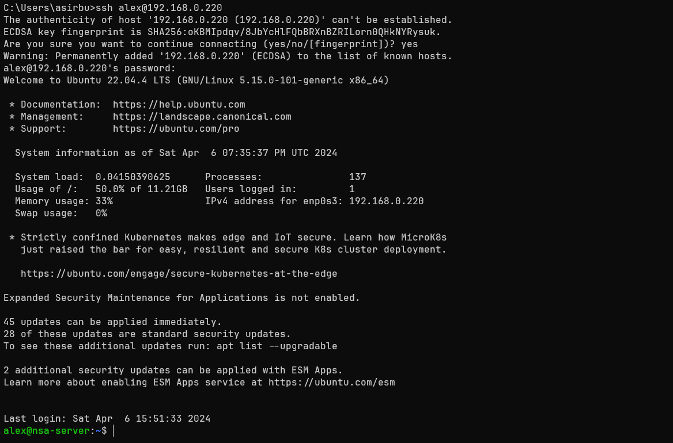

If everything works well, then the ssh server is installed.

You can try to create a folder on the ssh window from windows and then see that it is present also on the Linux machine.

## FTP server

Command: **sudo apt install vsftpd**

After successfully installed, go to the **/etc/vsftp.conf**  to configure the behavior of the server (set the flags **anonymous_enable** (if you want to let anonymous people access the server) and **write_enable** (if you want to let the users upload files)). Save the changes and restart the service using: **sudo systemctl restart vsftpd.service**.

After that check the status of the service: **sudo systemctl status vsftpd.service**.

Is should be green (active - (running))

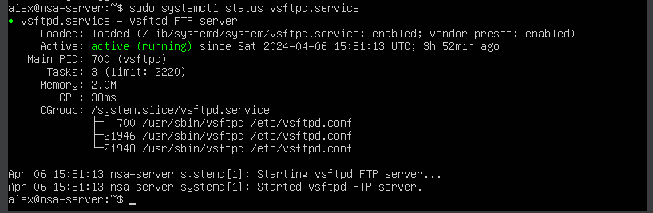

Now try to connect to the ftp server using a client or windows explorer

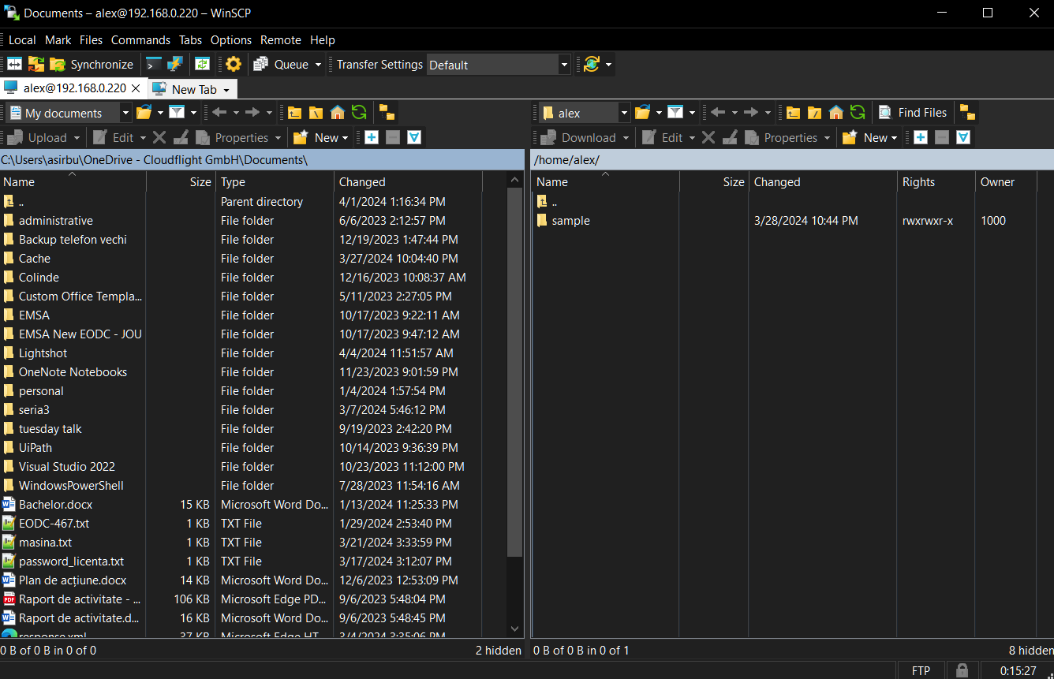

If everything works well then you have successfully connected and configured the FTP server. Now try to download a folder or a file from the server and upload another one instead

## DNS

Run the following commands to install the packages which are necessary for the DNS server to run

* **sudo apt install bind9**
* **sudo apt install dnsutils**

After they succeeded, configure in the following locations:

* /etc/bind/named.conf.options: global DNS options
* /etc/bind/named.conf.local: for your zones
* /etc/bind/named.conf.default-zones: default zones such as localhost, its reverse, and the root hints

Uncomment and edit **/etc/bind/named.conf.options** to set the IP addresses of your ISP’s DNS.

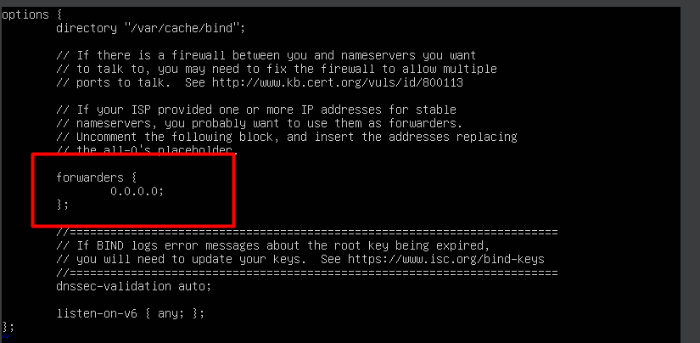

Check the installation using the dig –x 127.0.0.1

You should see something similar

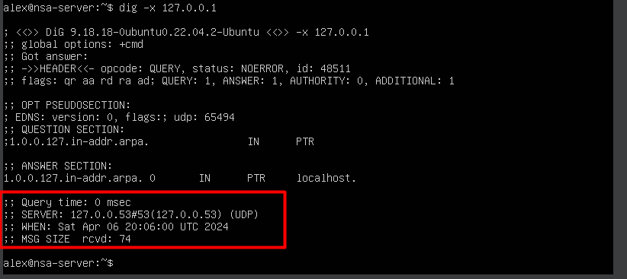

Restart the service and then check the availability of the system

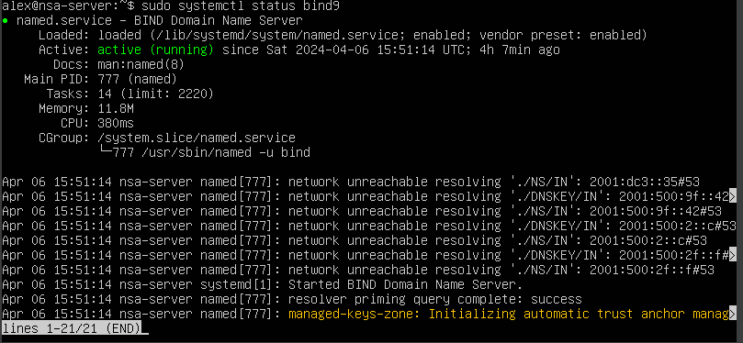

If it is green (active - (running)), you have successfully installed and configured a DNS server.

## DHCP

Run the command to install: **sudo apt install isc-dhcp-server**.

Go to **/etc/dhcp/dhcp.conf** and add (or uncomment) a configuration having the following format adapted to your subnet.

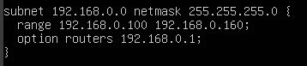

*Note*: if you do not know your configuration then run **ifconfig** and observe some important aspects.

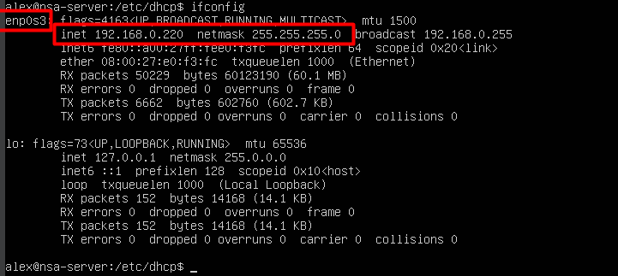

The first thing highlighted is the network interface and the second one is the address and the netmask (from here it should be easy to determine the network host and from where the IP pool should be.

Go to **/etc/default/isc-dhcp-server** and specify your interface for the **INTERFACESv4** entry.

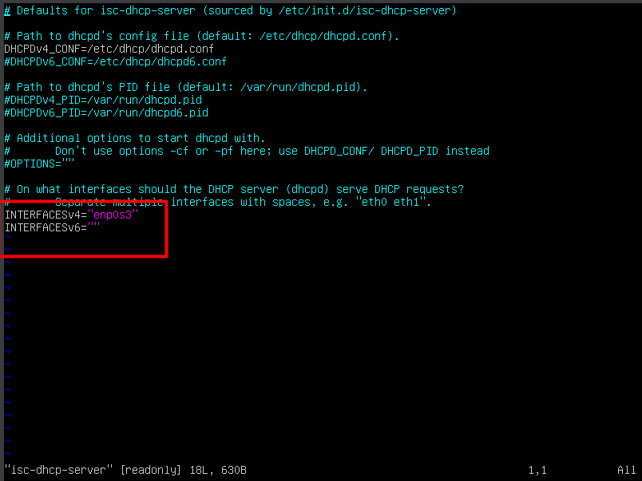*Note*: here instead of ”enp0s3” you should specify your actual interface (the one highlighted while running the **ifconfig** step).

After that restart the system (using: **sudo systemctl restart isc-dhcp-server.service**) then check the status (**sudo systemctl status isc-dhcp-server.service**), it should be green (active - (running)).

P.S. if any of these services are red, check the **/var/log/syslog** and look for logs containing relevant information for you.